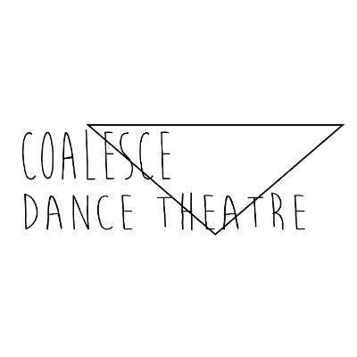
Director Recruitment Pack - Coalesce Dance Theatre
Thank you for your interest in this role. In this pack you will find information about Coalesce Dance Theatre, the role and responsibilities of a Director and the skills and attributes we are looking for. The closing date for applications is Monday 18 May at midday.
About Us
Coalesce Dance Theatre is an all-female identifying, LGBTQIA+, and disability-led contemporary dance company based in Manchester. We are dedicated to telling thought-provoking, physically powerful, and socially relevant stories through striking dance theatre performances. We focus our work on the physical, creative and emotional development of children and young people across the North West of England.
Coalesce Dance Theatre is in the process of becoming a Community Interest Company (CIC). A Community Interest Company is a limited company, with special additional features, created for those who want to conduct a business or other activity for community benefit and social good, and not purely for private advantage.
Vision and Mission
Coalesce Dance Theatre envisions a bold future where dance empowers young people to shape a more just, joyful, and sustainable world. Rooted in the North of England, we are building a leading contemporary dance company dedicated exclusively to children and young people. Through inclusive, high-quality dance experiences, we ignite creativity, nurture confidence and wellbeing, and amplify youth voices as a force for social and environmental change.
Our work connects communities, challenges inequality, and uses the power of movement to tell stories that matter, from climate justice to identity and belonging. We believe dance can be a radical act of hope, and we are here to inspire the next generation to move, lead, and reimagine the future.
Directors’ Role and Responsibilities
The role of Directors is to govern the CIC. Directors are responsible for the general control and management of the CIC, ensuring that it is solvent, well run, and delivers the charitable outcomes for which it has been set up for the benefit of the public.
Three Directors have worked on the application to become a CIC; we are now looking for two additional Directors to work collectively to guide the development of the company. The five Directors will comprise the two founding Co-Artistic Directors alongside three independent Directors. The Chair will always be an independent Director.
Normal term of office:
3 years from appointment.
Time Commitment:
Directors are expected to attend all meetings. These usually take place quarterly, with additional meetings arranged if required. Also expected to put in the necessary time to scrutinise papers ahead of these meetings, and to participate in telephone/email discussions between meetings. Directors are encouraged to take on additional responsibilities, matched with their knowledge, skills, experience and interests, as their time allows.
Person Specification
Individuals must have a strong empathy with the Coalesce Dance Theatre’s mission. All Directors should be aware of, and understand, their individual and collective responsibilities
Experience:
Directors should be able to demonstrate as many of the following as possible:
- successful experience of operating within a board in a charitable, public sector or commercial organisation;
- demonstrable experience of building and sustaining relationships with colleagues, partners and stakeholders to achieve organisational objectives;
- good listening skills;
- a proven track record of sound judgement and effective decision making;
- a history of impartiality, fairness and the ability to respect confidences; and a track record of commitment to promoting equality and diversity.
Knowledge and skills
Directors should be able to show:
- commitment to Coalesce Dance Theatre and its objectives;
- self-motivation;
- a willingness to devote the necessary time and effort to their duties;
- preparedness to speak their mind;
- a willingness to be available to other Directors and volunteers for advice and enquiries on an ad hoc basis;
- good, independent judgement and strategic vision;
- an understanding and acceptance of the legal duties, responsibilities and liabilities of Directorship;
- an ability and willingness to be an ambassador/advocate for the CIC, including through professional and/or personal networks;
- and an ability to work effectively as a member of a team.
How To Apply
To apply for the role, please submit:
- a letter and CV (no more than four sides of A4 in total)
- or a video (no more than eight minutes long)
Whether a letter or video, please tell us why you would like to be considered for this role and what attributes, skills and strengths you would bring to the role.
Please send written applications or videos as attachments to coalescedance@gmail.com by midday on Monday 18 May 2026. Online interviews will be held for shortlisted candidates in w/c 25 May.

